1. **List the name of employees who is not from ‘accounting’ division and work on project “web development”.**

**🡪**Select e.name  
from employee e  
join division d  
on d.did = e.did  
where lower(d.dname) <> 'accounting'  
and e.empid in (select w.empid from workon w join project p on p.pid = w.pid where lower(p.pname) = 'web development')

🡪

1. **List the name of divisions that have more than 2 employees with salary greater than $30000.**

**🡪**Select d.dname  
from division d  
join employee e  
on e.did = d.did  
where e.salary > 30000  
group by d.dname  
having count( e.empid ) > 2

🡪

1. **For each division (DID), List the name of project that has highest budget in that division and list the total number of employees who work on it.**

**🡪**

select d.did, p.pname, p.budget, count(*) as total_employees  
from division d  
join project p on d.did = p.did  
join workon w on p.pid = w.pid  
where p.budget = (select max(pp.budget) from project pp join division dd on dd.did = pp.did   
 where dd.did = d.did)  
group by d.did, p.pname, p.budget  
order by d.did

🡪  
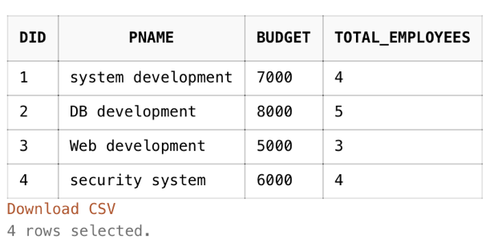

1. **List the name of employee make more salary than the average salary of employee working on project “Web development”.**

**🡪**

Select e.empid, e.name  
from employee e  
where e.salary > (select avg(ee.salary) from employee ee   
 where ee.empid in ( select w.empid from workon w join project p on p.pid = w.pid where   
 lower(p.pname) = 'web development'))

🡪

1. **List the name of manager whose salary is below his/her divisional salary.**

**🡪**Select e.name as Manager_Name  
from employee e  
join division d   
on d.did = e.did  
where d.managerid = e.empid  
and e.salary < (select avg(ee.salary) from employee ee join division dd on dd.did = ee.did where d.did =   
 dd.did)

🡪

1. **Among all projects ‘Accounting’ division has, list the name of project that has budget below company’s average project budget.**

**🡪**

Select p.pname, p.budget  
from project p   
join division d  
on d.did = p.did  
where lower(d.dname) = 'accounting'  
and p.budget < (select avg(pp.budget) from project pp)

🡪  


1. **List the name of employees and his/her division name if her/his works for more than 2 projects and salary is below company average.**

**🡪**Select e.name, d.dname  
from employee e  
join division d  
on d.did = e.did  
where e.empid in ( select w.empid from workon w group by w.empid having count(w.pid) > 2 )  
and e.salary < (select avg (ee.salary) from employee ee )

🡪

1. **List the name of Division t****hat has employee(s) who do not work on a project sponsored by his/her division.**

**🡪**

select distinct d.dname  
from employee e  
join division d on d.did = e.did  
join workon w on e.empid = w.empid  
join project p on p.pid = w.pid   
where p.did <> e.did  
group by d.dname  
order by d.dname

🡪  
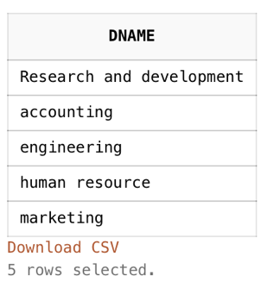

1. **List the name of employee whose salary is higher than all employees who work on the project “Wireless development”**

**🡪**

Select e.name  
from employee e  
where e.salary > all (select ee.salary from employee ee where ee.empid in  
 (select w.empid from workon w join project p on p.pid = w.pid   
 where lower(p.pname) = 'wireless development'))

🡪

1. **Using update statement to decrease the budget of a project sponsored by marketing division by 10% if there are less than 3 people working on it**

**🡪**

Update project

set budget = budget - (budget*0.1)

where budget in (Select p.budget

from project p

join division d

on d.did = p.did

where lower(d.dname) = 'marketing'

and p.pid in ( select w.pid from workon w group by w.pid having count(w.empid) < 3 ))

🡪

